#What is mean by network?
= If two or more device are connected with each other we called it network
--------------------------------------------------------------------------------------------------------------

#Network topology
= the way devices are connected and arranged in a network.
Types = bus, star, tree mesh, ring
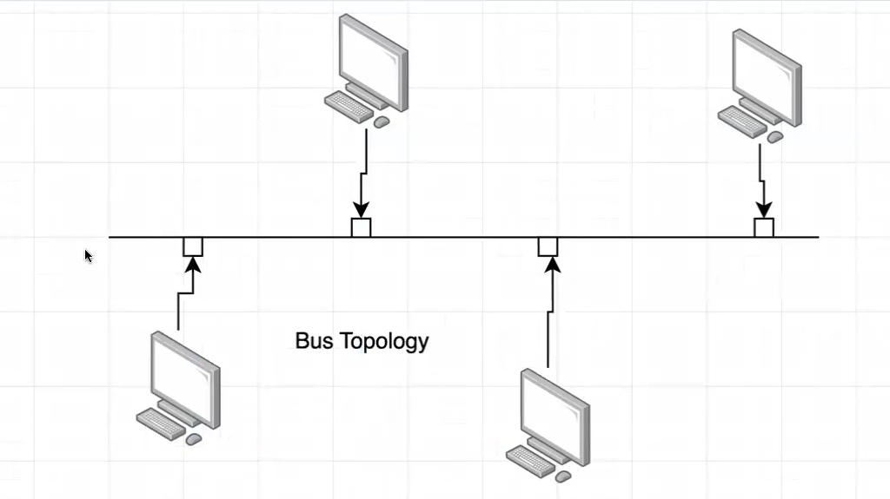
Simple Exam Definition
"Network topology refers to the physical or logical arrangement of devices and communication links in a network. The types of topology describe different ways devices are connected and organized."
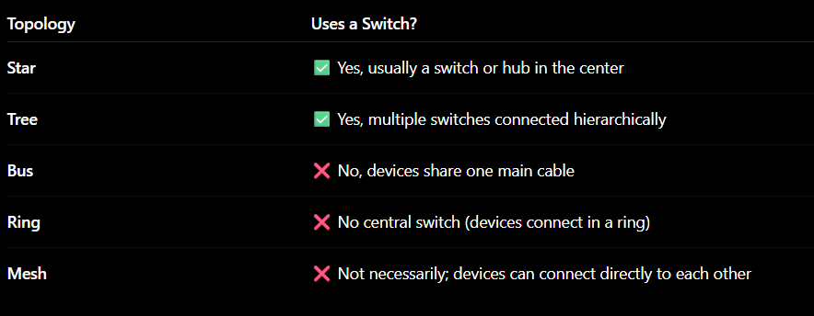
Switch ?
A switch is a networking device that connects multiple devices together in a network and sends data to the correct device. 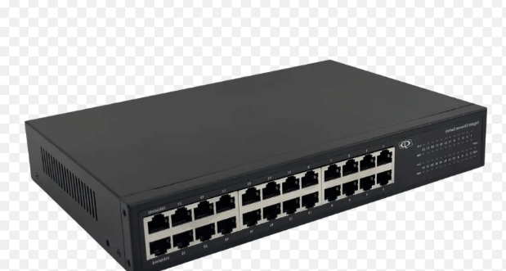
--------------------------------------------------------------------------------------------------------------

Network Types are classified based on the area they cover.
1. PAN (Personal Area Network)
- Very small range (a few meters).
- Connects personal devices.
Examples:
- Phone ↔ Bluetooth headset
- Phone ↔ Smartwatch
2. LAN (Local Area Network)
- Covers a small area like a home, office, or school.
- Usually uses switches and Ethernet/Wi-Fi.
Examples:
- Computer lab network
- Home Wi-Fi network
3. MAN (Metropolitan Area Network)
- Covers a city or large campus.
- Larger than LAN, smaller than WAN.
Examples:
- Network connecting multiple offices across a city
4. WAN (Wide Area Network)
- Covers countries or continents.
- Connects many LANs together.
Examples:
- The Internet
- A company's network across multiple countries
Easy Way to Remember
PAN < LAN < MAN < WAN
Smallest → Largest
--------------------------------------------------------------------------------------------------------------

Network Protocol
A network protocol is a set of rules that tells devices how to communicate with each other on a network.
Just like people need a common language and rules to have a conversation, computers need protocols to exchange data correctly.
What Does a Protocol Decide?
A network protocol defines:
- How data is sent
- How data is received
- How devices identify each other
- How errors are handled
- How data reaches the correct destination
Example
When you open a website:
- Your computer sends a request.
- The web server receives it.
- Both follow protocols such as HTTP/HTTPS and TCP/IP to communicate.
Common Network Protocols
- HTTP – Used for websites
- HTTPS – Secure web communication
- FTP – File transfer
- SMTP – Sending emails
- TCP/IP – Basic Internet communication
- TCP/IP works together as a protocol suite. TCP handles reliable data transfer, and IP finds the destination and routes the data.
--------------------------------------------------------------------------------------------------------------

What does TCP do?
TCP (Transmission Control Protocol) makes sure data is delivered correctly.
It:
- Sends data
- Checks whether it arrived
- Resends lost data
- Keeps data in the correct order
Example: Websites, email, file downloads

What does UDP do?
UDP (User Datagram Protocol) sends data as fast as possible.
It:
- Sends data
- Does not check if it arrived
- Does not resend lost data
- Does not guarantee order
Example: Online gaming, video calls, live streaming
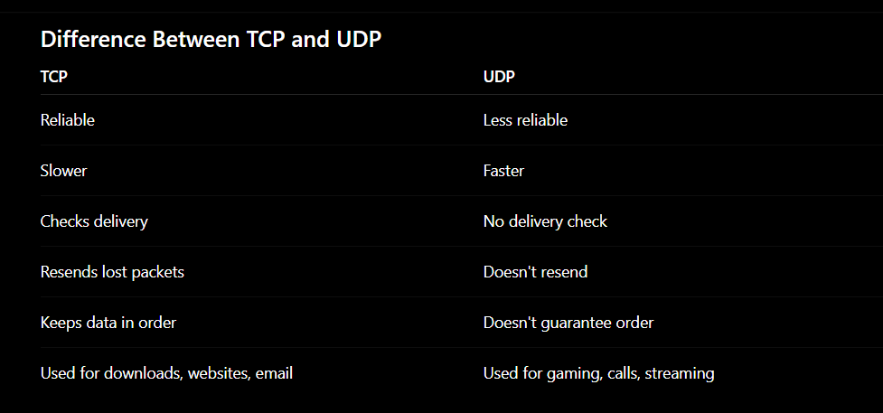
--------------------------------------------------------------------------------------------------------------

What is an IP Address?
An IP Address (Internet Protocol Address) is a unique number assigned to a device on a network.
It helps identify a device and tells data where to go.

--------------------------------------------------------------------------------------------------------------

Types of Ip address:-
Dynamic IP Address
Most home Internet connections use dynamic IP addresses.
- The IP can change.
- Your ISP (Internet Service Provider) assigns it.
- It may change when you restart your router or after some time.
Static IP Address
Some devices or servers use static IP addresses.
- The IP stays the same.
- Common for servers, businesses, and websites.
--------------------------------------------------------------------------------------------------------------

Logical Address (IP Address)
- Can change
- Used for communication on a network
- Example: 192.168.1.10
Physical Address (MAC Address)
- Usually fixed by the manufacturer
- Identifies the network card/device
- Example: 00:1A:2B:3C:4D:5E

--------------------------------------------------------------------------------------------------------------

IPV4 & IPV6
IPv4 and IPv6 are versions of the Internet Protocol used to assign addresses to devices and route data across networks. IPv4 uses 32-bit addresses, while IPv6 uses 128-bit addresses and supports many more devices
IPv4 and IPv6 are Internet Protocol versions used to assign logical IP addresses to devices on a network.
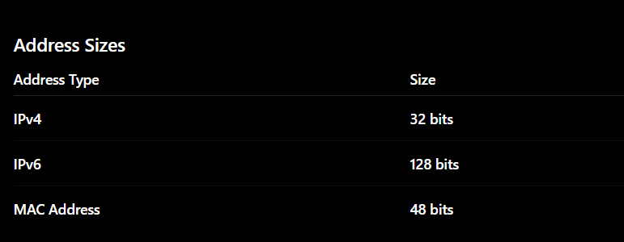
Ifconfig to check your ip address in linux !!!
--------------------------------------------------------------------------------------------------------------

Private IP Address
A private IP address is assigned by a router to devices within a local network such as a home, office, or school. It is used for communication inside that network and is not directly accessible from the Internet.
Examples:
- 192.168.1.10
- 10.0.0.5

--------------------------------------------------------------------------------------------------------------

Public IP Address
A public IP address is assigned by an ISP (Internet Service Provider) such as Jio, Airtel, or BSNL. It is used to communicate over the Internet and can be reached from outside the local network.
Example:
- 49.x.x.x

#IMP
HOMEWORK
Learn all default Ports till 2000 port

